## PRACTICAL NO-1

**AIM :** Implementation of Class Diagram for Hotel management system.

**THEORY :**

The class diagram is a static diagram. It represents the static view of an application. Class diagram is not only used for visualizing, describing and documenting different aspects of a system but also for constructing executable code of the software application.

The class diagram shows a collection of classes, interfaces, associations, collaborations and constraints. It is also known as a *structural diagram*.

**So the purpose of the class diagram can be summarized as:**

* Analysis and design of the static view of an application.
* Describe responsibilities of a system.
* Base for component and deployment diagrams.
* Forward and reverse engineering.

## How to draw Class Diagram?

The following points should be remembered while drawing a class diagram:

* The name of the class diagram should be meaningful to describe the aspect of the system.
* Each element and their relationships should be identified in advance.
* Responsibility (attributes and methods) of each class should be clearly identified.
* For each class minimum number of properties should be specified. Because unnecessary properties will make the diagram complicated.
* Use notes when ever required to describe some aspect of the diagram. Because at the end of the drawing it should be understandable to the developer/coder
* Finally, before making the final version, the diagram should be drawn on plain paper and rework as many times as possible to make it correct.

**Associations :**

Associations represent static relationships between classes. Place association names above, on, or below the association line. Use a filled arrow to indicate the direction of the relationship. Place roles near the end of an association. Roles represent the way the two classes see each other.

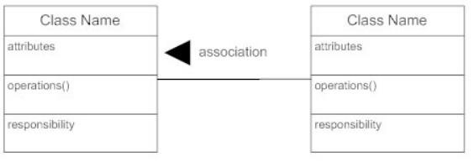

**Object :**

An object, then, the Animal can have individual objects like cow, lion, dog etc. These are object not only because it has different names, but also because they have different values assigned to their properties.

**Class :**

|  |
| --- |
| Class Name |
| attributes |
| Opretions() |

A class is a blueprint from which you can create the instance, i.e., objects. A class is used to bind data as well as methods together as a single unit. The class has to be declared only once. Class diagrams provide a graphic notation for modeling classes and their relationships. The UML symbol for a class is a box.

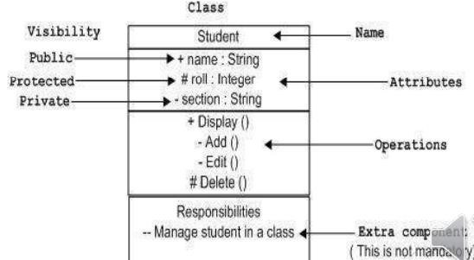

Active classes initiate and control the flow of activity, while passive classes store data and serve other classes. Illustrate active classes with a thicker border.

**Generalization & Specialization :**

Generalization uses a “is-a” relationship from a specialization to the generalization class. Common structure and behavior are used from the specialization to the generalized class. At a very broader level you can understand this as inheritance. Why I take the term inheritance is, you can relate this term very well. Generalization is also called a “Is-a” relationship.

Specialization is the reverse process of Generalization means creating new sub-classes from an existing class. For Example, a Bank Account is of two types - Savings Account and Credit Card Account. Savings Account and Credit Card Account inherit the common/ generalized properties like Account Number, Account Balance, etc. from a Bank Account and also have their specialized properties like unsettled payment etc.

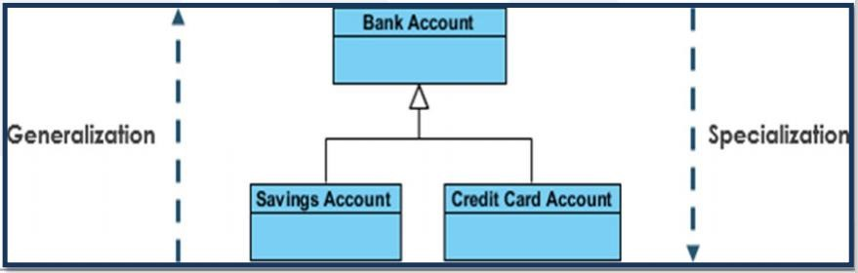

**Aggregation :**

Aggregation is a special type of association that models a whole- part relationship between aggregate and its parts.

For example, the class college is made up of one or more student. In aggregation, the contained classes are never totally dependent on the lifecycle of the container. Here, the college class will remain even if the student is not available.

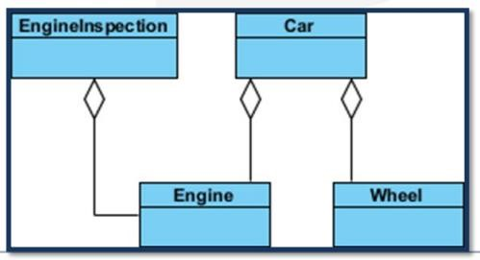

**Composition :**

The composition is a special type of aggregation which denotes strong ownership between two classes when one class is a part of another class.

For example, if college is composed of classes student. The college could contain many students, while each student belongs to only one college. So, if college is not functioning all the students also removed.

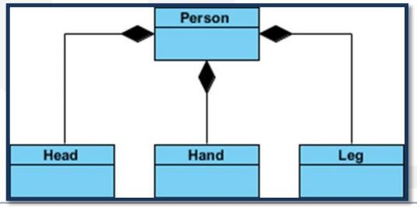

**Class Diagram for Hotel management system.**

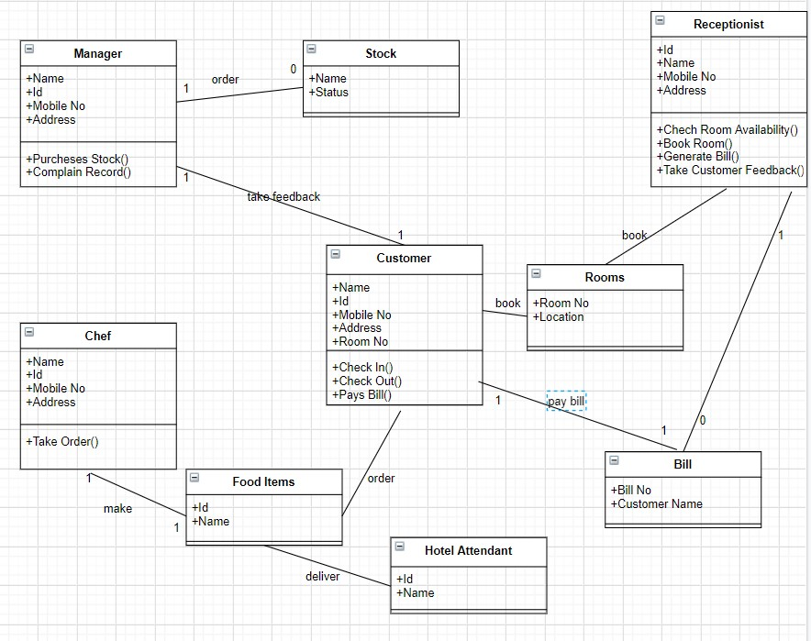

## PRACTICAL NO-2

**AIM :** Implementation of Object Diagram for Order management system.

**THEORY :**

The name of the diagram itself clarifies the purpose of the diagram and other details. It describes different states of a component in a system. The states are specific to a component/object of a system.

A State chart diagram describes a state machine.

Object diagrams are derived from class diagrams so object diagrams are dependent upon class diagrams.

Object diagrams represent an instance of a class diagram. The basic concepts are similar for class diagrams and object diagrams. Object diagrams also represent the static view of a system but this static view is a snapshot of the system at a particular moment.

So the purpose of the object diagram can be summarized as:

* Forward and reverse engineering.
* Object relationships of a system
* Static view of an interaction.
* Understand object behaviour and their relationship from practical perspective

## How to draw Object Diagram?

* First, analyse the system and decide which instances are having important data and association.
* Second, consider only those instances which will cover the functionality.
* Third, make some optimization as the numbers of instances are unlimited.

It has the following objects

* Customer
* Order
* Specialorder
* NormalOrder

Example:

* Now the customer object (C) is associated with three order objects (O1, O2 and O3). These order objects are associated with special order and normal order objects (S1, S2 and N1). The customer is having the following three orders with different numbers (12, 32 and 40) for the particular time considered.
* Now the customer can increase number of orders in future and in that scenario the object diagram will reflect that. If order, special order and normal order objects are observed then you will find that they are having some values.
* For orders the values are 12, 32, and 40 which implies that the objects are having these values for the particular moment (here the particular time when the purchase is made is considered as the moment) when the instance is captured.
* The same is for special order and normal order objects which are having number of orders as 20, 30 and 60. If a different time of purchase is considered then these values will change accordingly.
* So the following object diagram has been drawn considering all the points mentioned above:

Object diagram shows this relation between the instantiated classes and the defined class, and the relation between these objects in the system. They are be useful to explain smaller portions of your system, when your system class diagram is very complex, and also sometimes modeling recursive relationship in diagram. Before you create a class diagram, you might create an object diagram to discover facts about specific examples of the classifiers that are required.

**Object Attributes :**

Similar to classes, you are able to list object attributes inside a separate compartment. However, unlike classes, object attributes should have values assign for them.

**Object Names :**

Every object actually symbolized like a rectangle, that offers the name from the object and its class underlined as well as divided with a colon. Obj Name: Class name, ex: Disha:Student.

**Object Diagram for Order management system.**

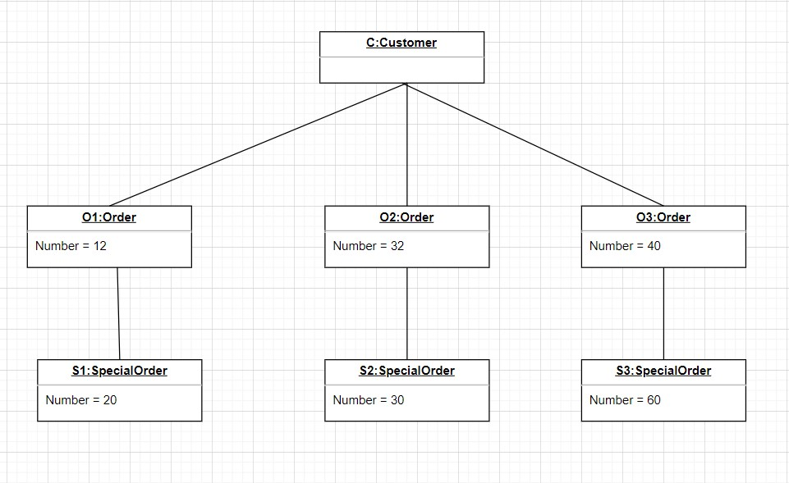

## PRACTICAL NO-3

**AIM :** Implementation of State Diagram for Hotel Management system.

**THEORY :**

**Initial state :** We use a black filled circle represent the initial state of a system.



**Transition :** we use a solid arrow to represent the transition or change of control from one state to another.

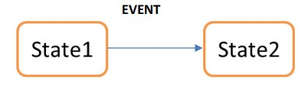

**Self transition :** We use a solid arrow pointing back to the state itself to represent a self transition. Composite state: We use a rounded rectangle to represent a composite state also

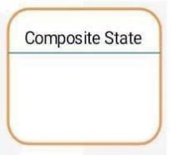

**State :** We use a rounded rectangle to represent a state.

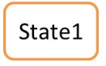

**Join :** We use a rounded solid rectangular bar to represent a join notation with incoming arrows from the joining state and outgoing arrow towards the common goal state

**Fork :** we use a rounded solid rectangular bar to represent a fork notation with incoming arrow from the parent state and outgoing arrows towards the newly created states.

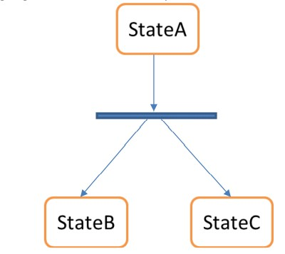

**Final State:** we use a filled circle within a circle notation to represent the final state in a state machine diagram.



**State Diagram for Hotel Management system.**

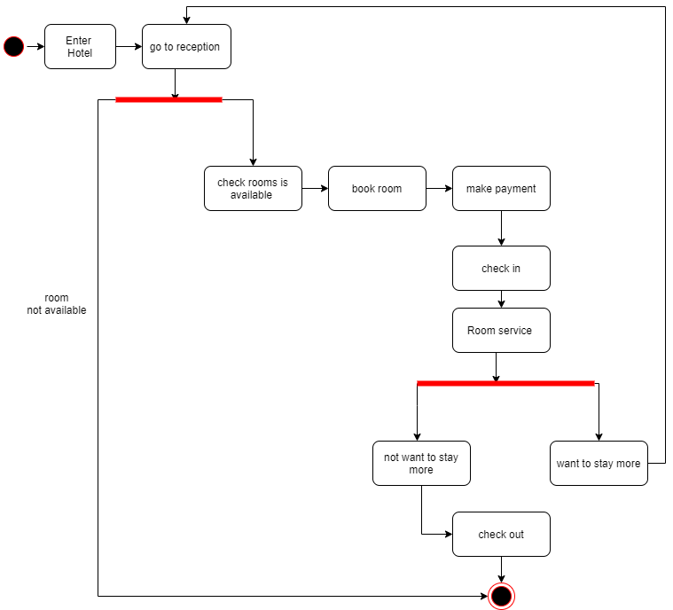

## PRACTICAL NO-4

**AIM :** Implementation of Use-Case Diagram for Library Management system.

**THEORY :**

The purpose of use case diagram is to capture the dynamic aspect of a system. But this definition is too generic to describe the purpose.

Because other four diagrams (activity, sequence, collaboration and State chart) are also having the same purpose. So we will look into some specific purpose which will distinguish it from other four diagrams.

Relationships among the use cases and actors.

**Goals:**

The end result of most use cases. A successful diagram should describe the activities and variants used to reach the goal.

**System boundary boxes:**

A box that sets a system scope to use cases. All use cases outside the box would be considered outside the scope of that system.

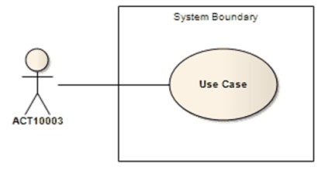

**Actors:**

Stick figures that represent the people actually employing the use cases.

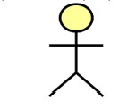

**Use cases:**

Horizontally shaped ovals that represent the different uses that a user might have.

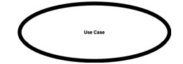

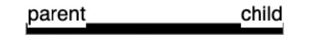

**System:**

A specific sequence of actions and interactions between actors and the system. A system may also be referred to as a scenario.

**Packages:**

A UML shape that allows you to put different elements into groups. Just as with component diagrams, these groupings are represented as file folders.

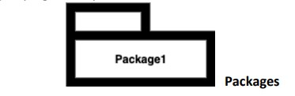

**Associations:**

A line between actors and use cases. In complex diagrams, it is important to know which actors are associated with which use cases.

**How to draw Use Case Diagram?**

Use case diagrams are considered for high level requirement analysis of a system. So when the requirements of a system are analysed the functionalities are captured in use cases.

So, we can say that use cases are nothing but the system functionalities written in an organized manner. Now the second things which are relevant to the use cases are the actors. Actors can be defined as something that interacts with the system.

The actors can be human user, some internal applications or may be some external applications. So, in a brief when we are planning to draw an use case diagram we should have the following items identified.

* Functionalities to be represented as a use case
* Actors
* Relationships among the use cases and actors.

Use case diagrams are drawn to capture the functional requirements of a system. So, after identifying the above items we must follow the following guidelines to draw an efficient use case diagram.

* The name of a use case is very important. So, the name should be chosen in such a way so that it can identify the functionalities performed.
* Give a suitable name for actors.
* Show relationships and dependencies clearly in the diagram.
* Do not try to include all types of relationships. Because the main purpose of the diagram is to identify requirements.
* Use note whenever required to clarify some important points.

**Use-Case Diagram for Library Management system.**

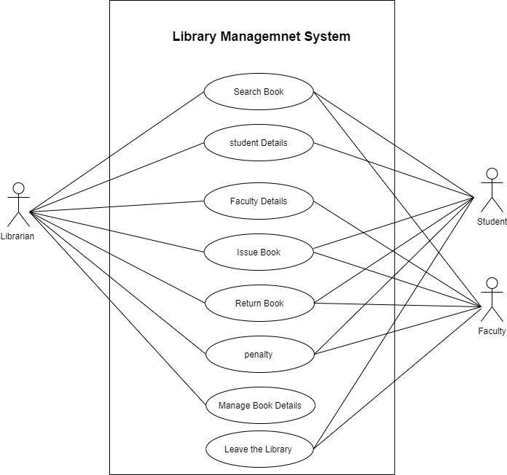

## PRACTICAL NO-5

**AIM :** Implementation of Sequence Diagram for Hospital management system.

**THEORY :**

Sequence diagrams describe interactions among classes in terms of an exchange of messages over time. They're also called event diagrams. A sequence diagram is a good way to visualize and validate various runtime scenarios

## How to Use Sequence Diagrams

* Model and document how your system will behave in various scenarios
* Validate the logic of complex operations and functions

## Basic Sequence Diagram Symbols and Notations

**Class Roles or Participants**  
Class roles describe the way an object will behave in context. Use the UML object symbol to illustrate class roles, but don't list object attributes.

Object symbol - Sequence diagram

**Activation or Execution Occurrence**  
Activation boxes represent the time an object needs to complete a task. When an object is busy executing a process, or waiting for a reply message, use a thin grey rectangle placed vertically on its lifeline.

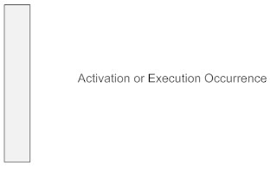

**Messages**  
Messages are arrows that represent communication between objects. Use half-arrowed lines to represent asynchronous messages. Asynchronous messages are sent from an object that will not wait for a response from the receiver before continuing its tasks. For message types, see below.

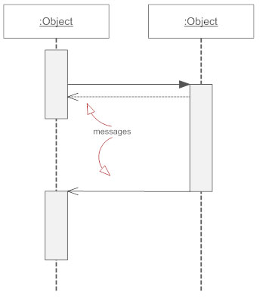

**Lifelines**  
Lifelines are vertical dashed lines that indicate the object's presence over time.

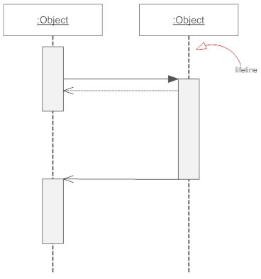

**Destroying Objects**  
Objects can be terminated early using an arrow labeled "<< destroy >>" that points to an X. This object is removed from memory. When that object's lifeline ends, you can place an X at the end of its lifeline to denote a destruction occurrence.

**Loops**  
A repetition or loop within a sequence diagram is depicted as a rectangle. Place the condition for exiting the loop at the bottom left corner in square brackets [ ].

## Types of Messages in Sequence Diagrams

**Synchronous Message**  
A synchronous message requires a response before the interaction can continue. It's usually drawn using a line with a solid arrowhead pointing from one object to another.

Synchronous message - Sequence diagram

**Asynchronous Message**  
Asynchronous messages don't need a reply for interaction to continue. Like synchronous messages, they are drawn with an arrow connecting two lifelines; however, the arrowhead is usually open and there's no return message depicted.

Simple messageAsyncrhonous message

**Reply or Return Message**  
A reply message is drawn with a dotted line and an open arrowhead pointing back to the original lifeline.

Reply messages

**Self Message**  
A message an object sends to itself, usually shown as a U shaped arrow pointing back to itself.

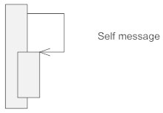

**Create Message**  
This is a message that creates a new object. Similar to a return message, it's depicted with a dashed line and an open arrowhead that points to the rectangle representing the object created.

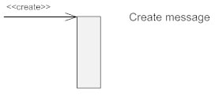

**Delete Message**  
This is a message that destroys an object. It can be shown by an arrow with an x at the end.

Delete message

**Found Message**  
A message sent from an unknown recipient, shown by an arrow from an endpoint to a lifeline.

Found message

**Lost Message**  
A message sent to an unknown recipient. It's shown by an arrow going from a lifeline to an endpoint, a filled circle or an x.

Lost message

**Sequence Diagram for Hospital management system.**

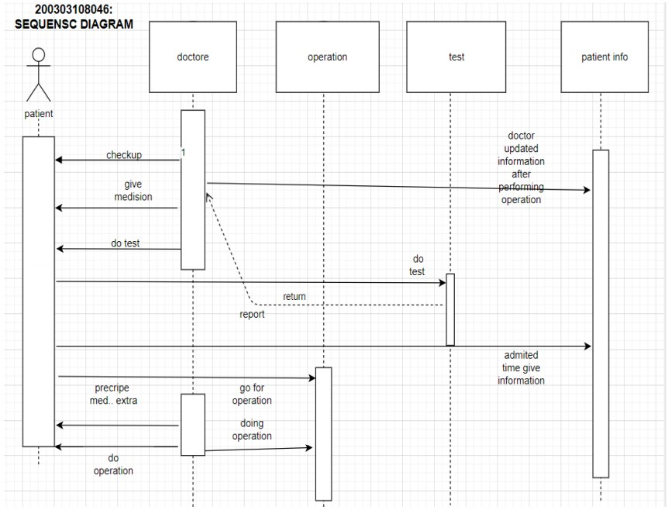

**Practical 7**

**AIM: Implementation of Collaboration Diagram**

**Overview:** This interactive behaviour is represented in UML by two diagrams known as Sequence diagram and Collaboration diagram. The basic purposes of both the diagrams are similar.

Collaboration diagram emphasizes on the structural organization of the objects that send and receive messages.

## Purpose: The purposes of interaction diagrams are to visualize the interactive behaviour of the system. Now visualizing interaction is a difficult task. So, the solution is to use different types of models to capture the different aspects of the interaction.

So, the purposes of interaction diagram can be describes as:

* To capture dynamic behaviour of a system.
* To describe the message flow in the system.
* To describe structural organization of the objects.
* To describe interaction among objects.

**Collaboration Diagram**

The Collaboration diagram is having four objects (Customer, Order, SpecialOrder and NormalOrder).The following diagram has shown the message sequence for *SpecialOrder* object and the same can be used in case of *NormalOrder* object. The first call is *sendOrder ()* which is a method of *Order* object. The next call is*confirm ()* which is a method of *SpecialOrder* object and the last call is *Dispatch ()* which is a method of *SpecialOrder* object. It shows the object organization as shown below. Here in collaboration diagram the method call sequence is indicated by some numbering technique as shown below. The number indicates how the methods are called one after another. We have taken the same order management system to describe the collaboration diagram. The method calls are similar to that of a sequence diagram. But the difference is that the sequence diagram does not describe the object organization whereas the collaboration diagram shows the object organization. Now to choose between these two diagrams the main emphasis is given on the type of requirement. If the time sequence is important then sequence diagram is used and if organization is required, then collaboration diagram is used.

**Collaboration Diagram for Hotel Reservation System**

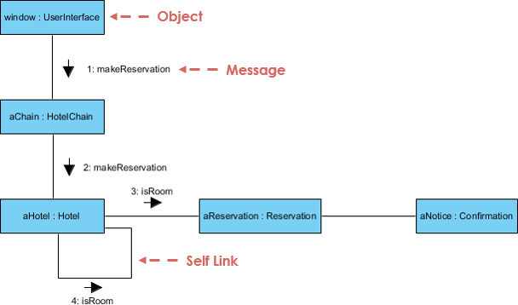

**Practical No: 8**

**Aim:** Study of Domain Class Model & Domain State Model.

Domains and Domain Models

A domain is a collection of related concepts, relationships, and workflows.

Examples of domains include:Science, engineering, medicine, business, government, military

A domain model is a package containing class and activity diagrams.For example, the education domain can be modelled by a package:

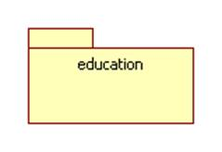

This package contains the following class diagram which models the concepts of school, university, instructor, and student as well as the relationships teaches-at, teaches, and enrolled-at: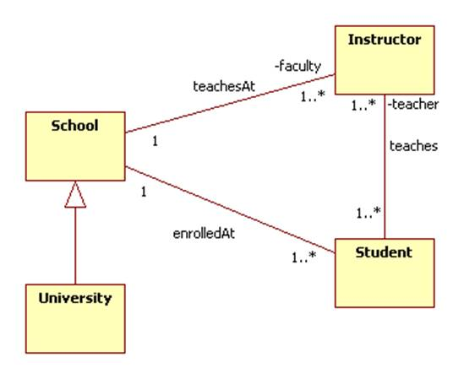

It also contains the following activity diagram that represents the student workflow: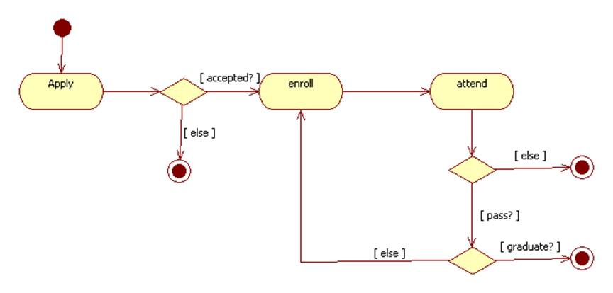

### **Dependencies between Domains**

Domains can import elements from other domains. This can be shown by a package diagram. A package diagram is a class diagram that shows packages and the dependencies between them.A dependency between two packages is represented by a dashed arrow. More specifically, dashed arrow from package A to package B indicates that package A uses some of the items contained in package B. We say that A imports from B or that B exports to A.

Here are a few examples:

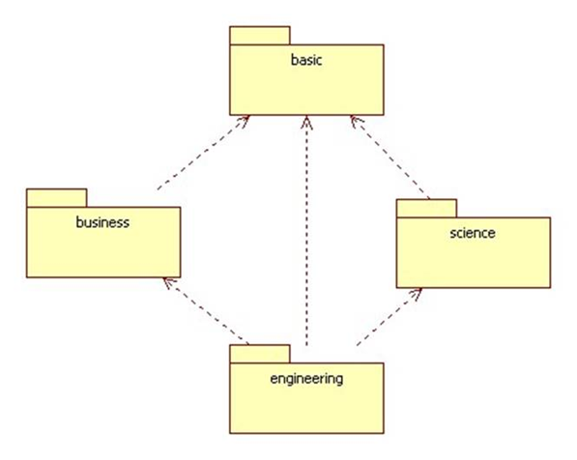

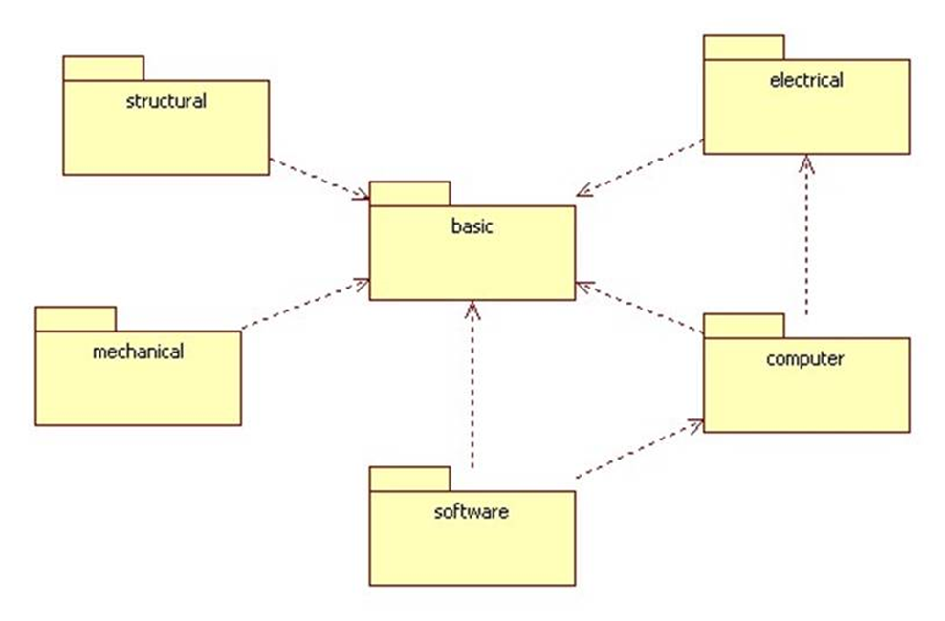

**Practical No: 9**

**AIM: Study of Rational Tool.**

Rational Rose is an object-oriented Unified Modeling Language (UML) software design tool intended for visual modeling and component construction of enterprise-level software applications.

In much the same way a theatrical director blocks out a play, a software designer uses Rational Rose to visually create (model) the framework for an application by blocking out classes with actors (stick figures), use case elements (ovals), objects (rectangles) and messages/relationships (arrows) in a sequence diagram using drag-and-drop symbols.

Rational Rose documents the diagram as it is being constructed and then generates code in the designer's choice of C++, Visual Basic, Java, Oracle8, Corba or Data Definition Language.

**Practical No: 10**

**Aim:** Study of MVC Design Pattern.

**Model–View–Controller** (usually known as MVC) is an [architectural pattern](https://en.wikipedia.org/wiki/Architectural_pattern) commonly used for developing [user interfaces](https://en.wikipedia.org/wiki/User_interface) that divides an application into three interconnected parts. This is done to separate internal representations of information from the ways information is presented to and accepted from the user. The MVC design pattern decouples these major components allowing for [code reuse](https://en.wikipedia.org/wiki/Code_reuse) and parallel development.

Traditionally used for desktop [graphical user interfaces](https://en.wikipedia.org/wiki/Graphical_user_interface) (GUIs), this architecture has become popular for designing [web applications](https://en.wikipedia.org/wiki/Web_application). Popular programming languages like [JavaScript](https://en.wikipedia.org/wiki/JavaScript), [Python](https://en.wikipedia.org/wiki/Python_(programming_language)), [Ruby](https://en.wikipedia.org/wiki/Ruby_(programming_language)), [PHP](https://en.wikipedia.org/wiki/PHP), [Java](https://en.wikipedia.org/wiki/Java_(programming_language)), and [C#](https://en.wikipedia.org/wiki/C_Sharp_(programming_language)) have MVC frameworks that are used in web application development straight [out of the box](https://en.wikipedia.org/wiki/Out_of_the_box_(feature)).

**Model**

The central component of the pattern. It is the application's dynamic data structure, independent of the user interface. It directly manages the data, logic and rules of the application.

**View**

Any representation of information such as a chart, diagram or table. Multiple views of the same information are possible, such as a bar chart for management and a tabular view for accountants.

**Controller**

Accepts input and converts it to commands for the model or view.

